**EXPERIMENT-3**

**Title: 3. To understand and use SQL Sub-Query**

**1. Create the following table:**

**Supplier-(scode,sname,scity,turnover)**

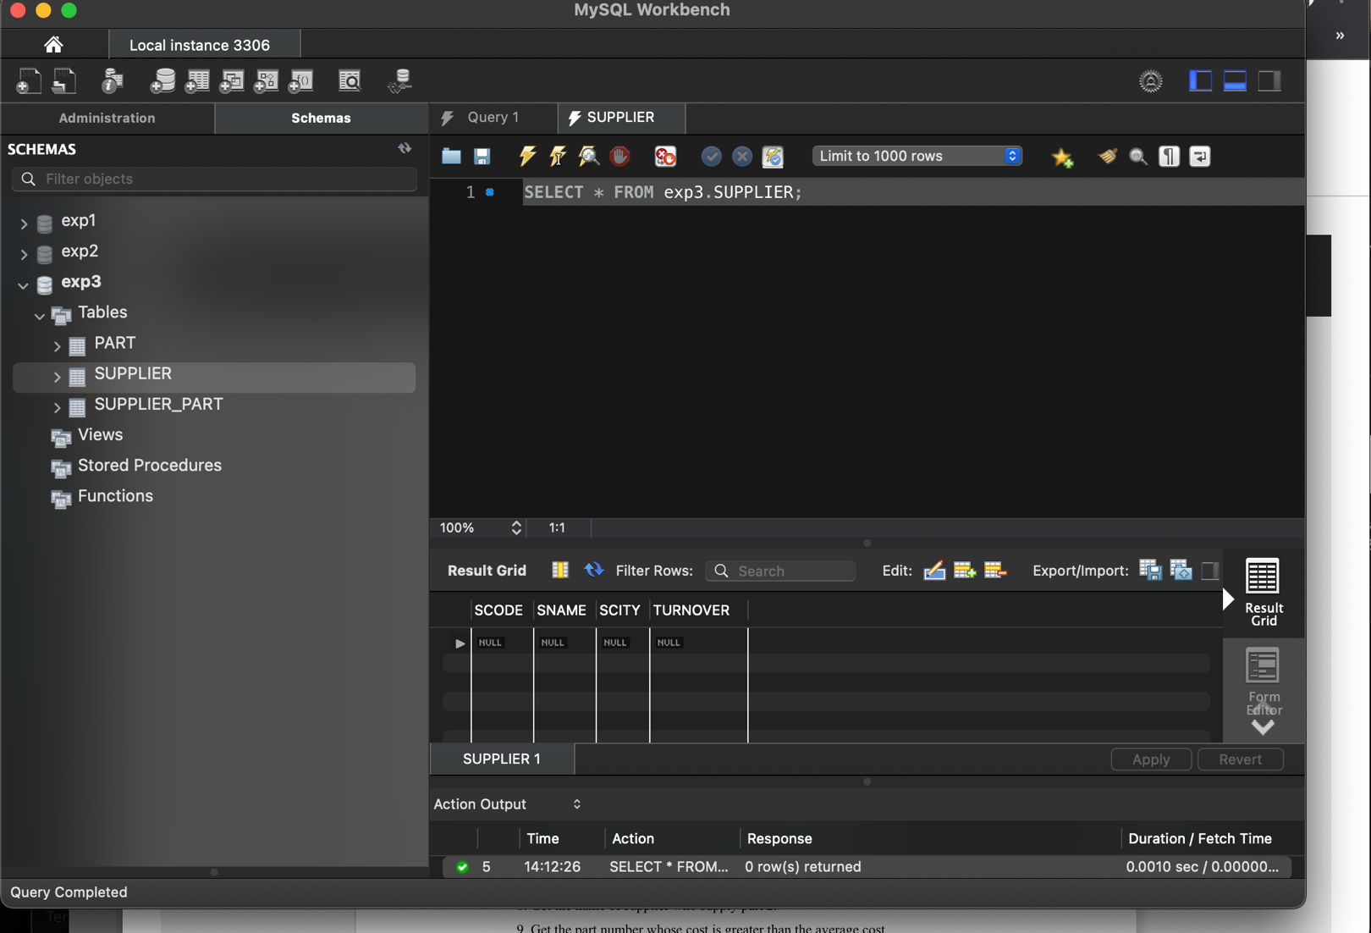

**Part-(pcode,weigh,color,cost,sellingprice)**

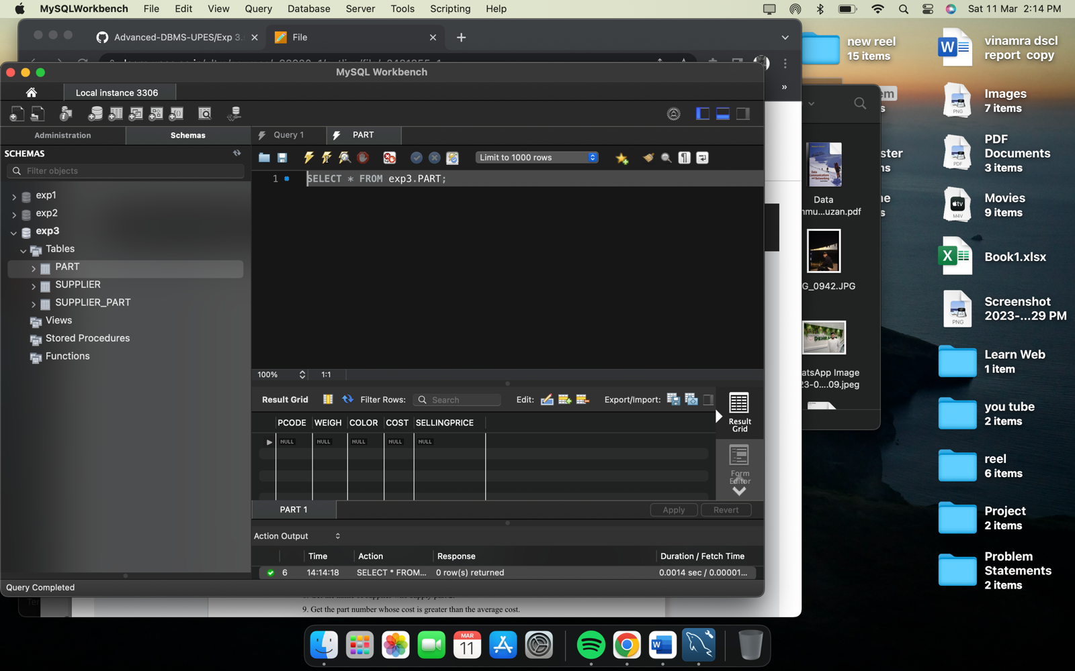

**Supplier_Part-(scode,pcode,qty)**

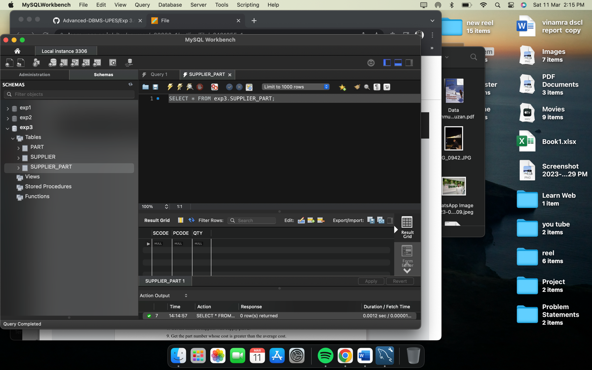

**2. Populate the table:**

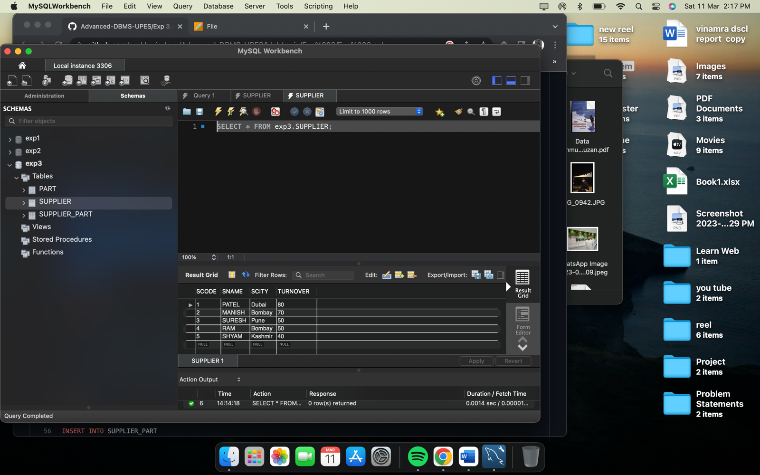

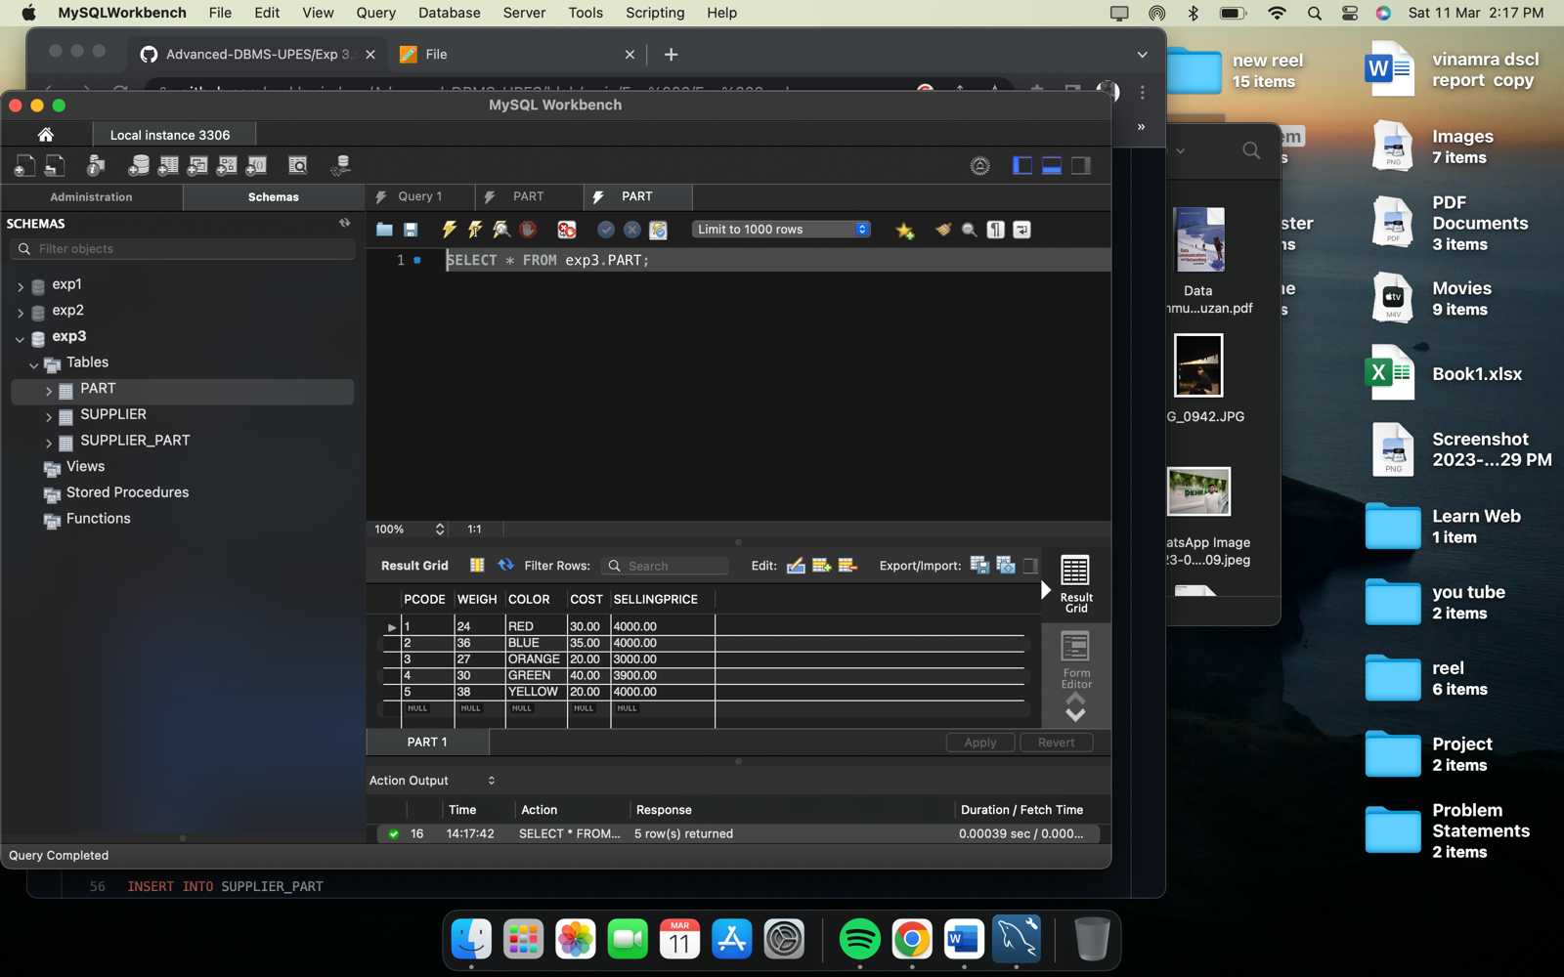

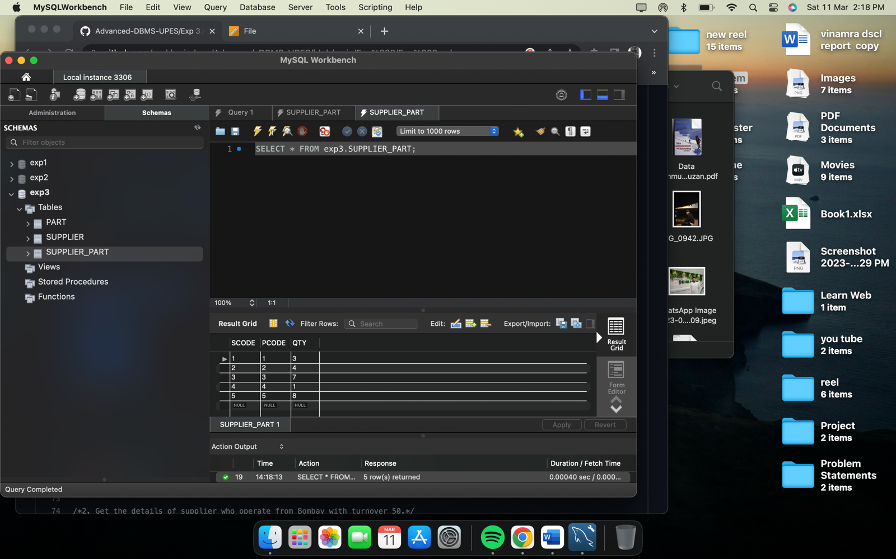

**3. Write appropriate SQL Statement for the following:**

* **Get the supplier number and part number in ascending order of supplier number**

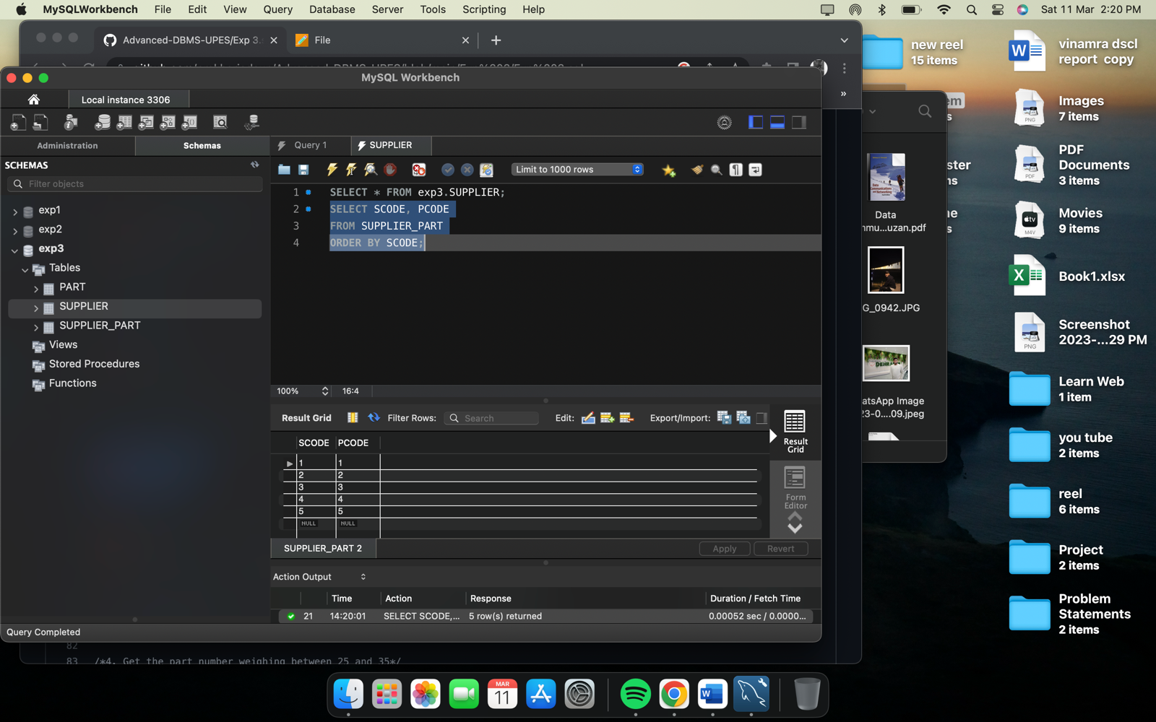

* **Get the details of supplier who operate from Bombay with turnover 50.**

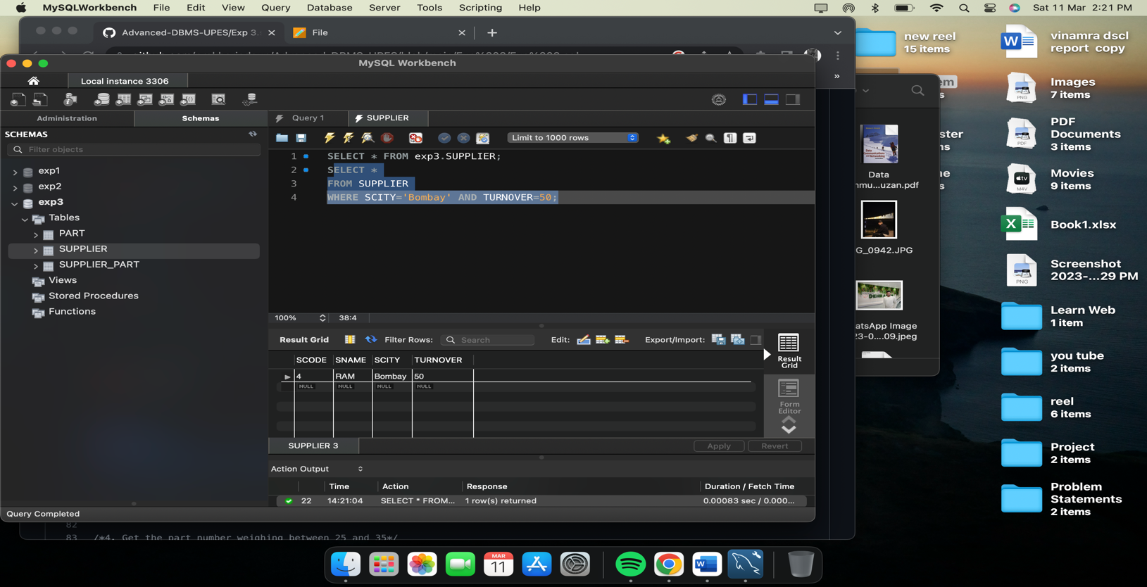

* **Get the total number of supplier.**

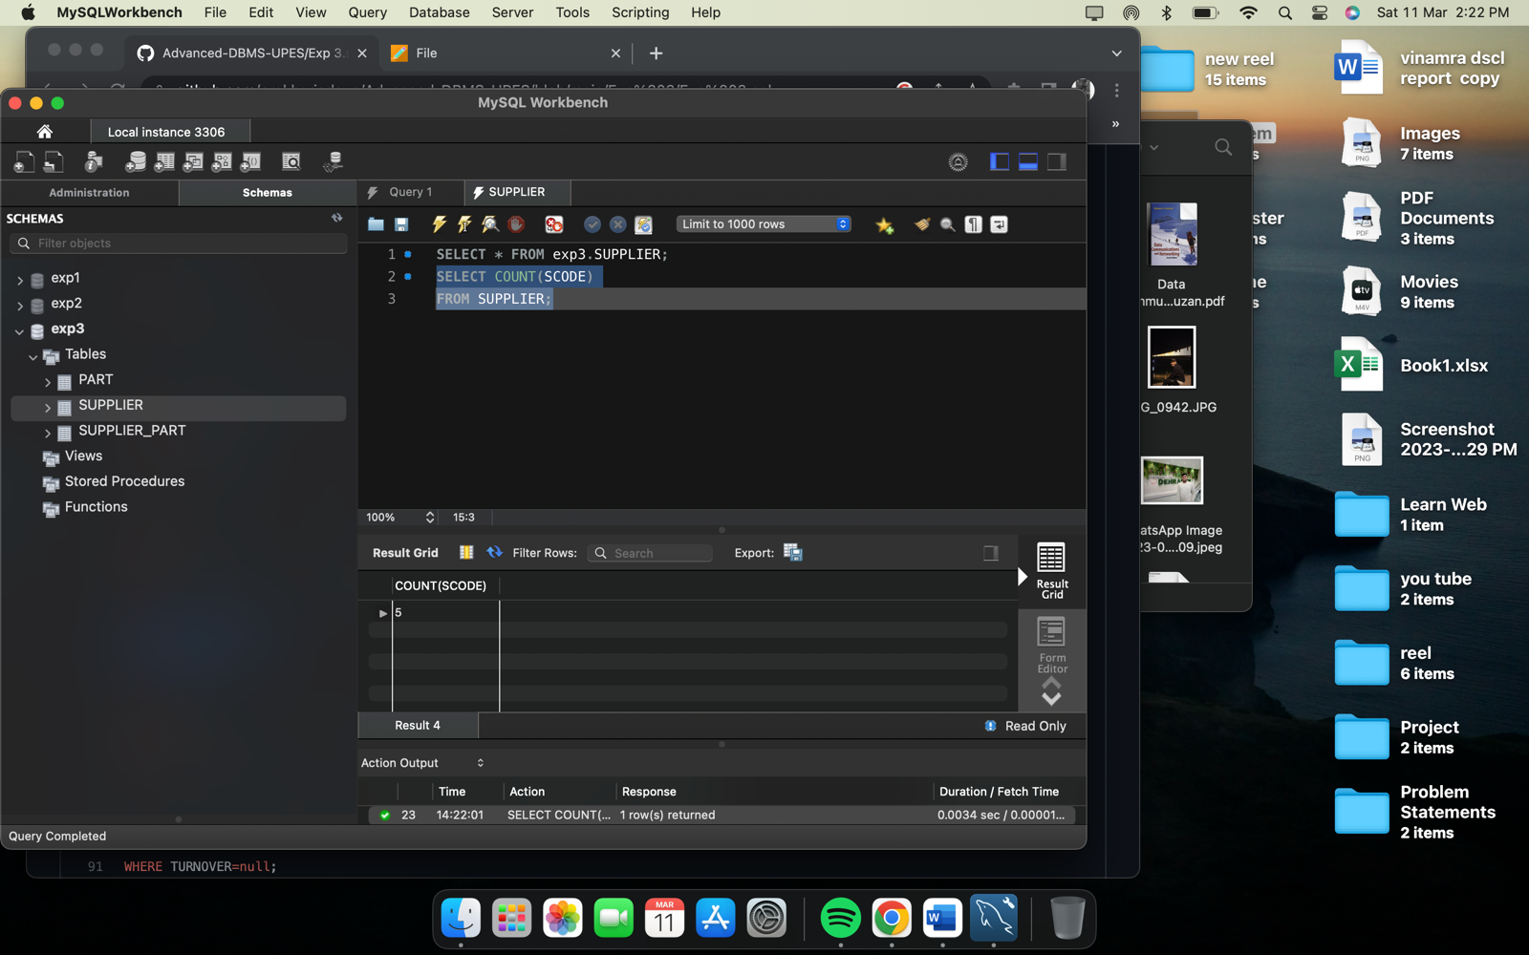

* **Get the part number weighing between 25 and 35.**

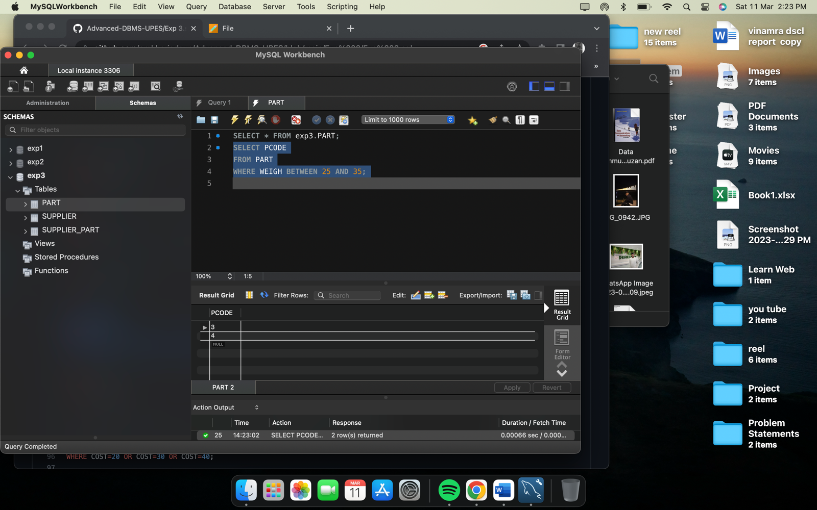

* **Get the supplier number whose turnover is null.**

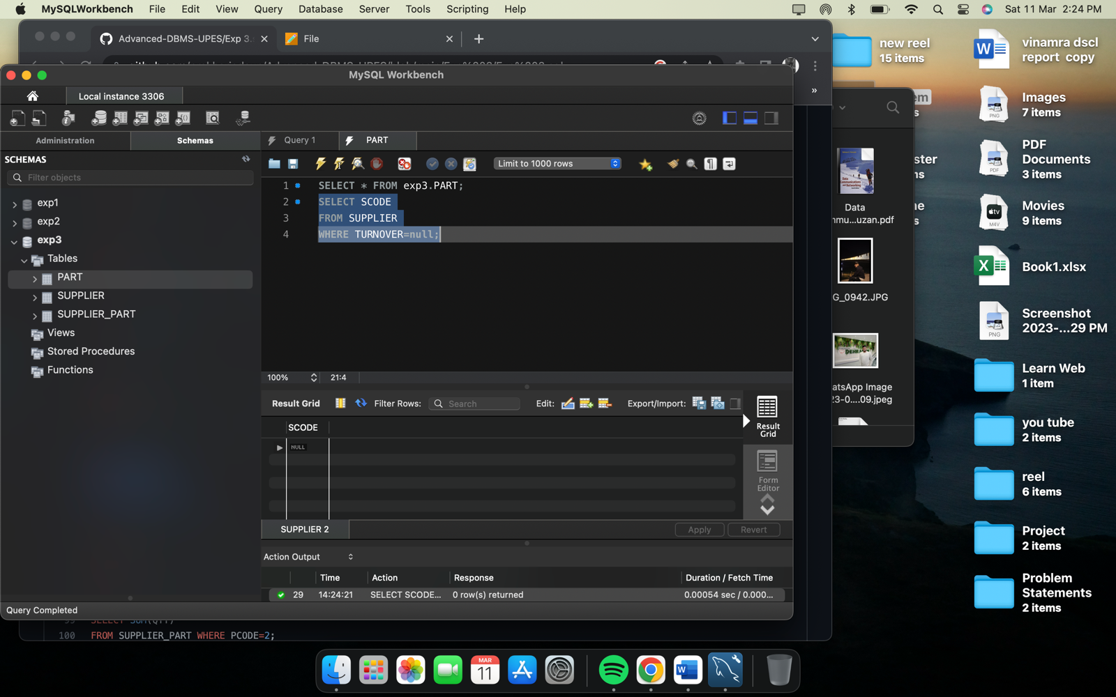

* **Get the part number that cost 20, 30 or 40 rupees**

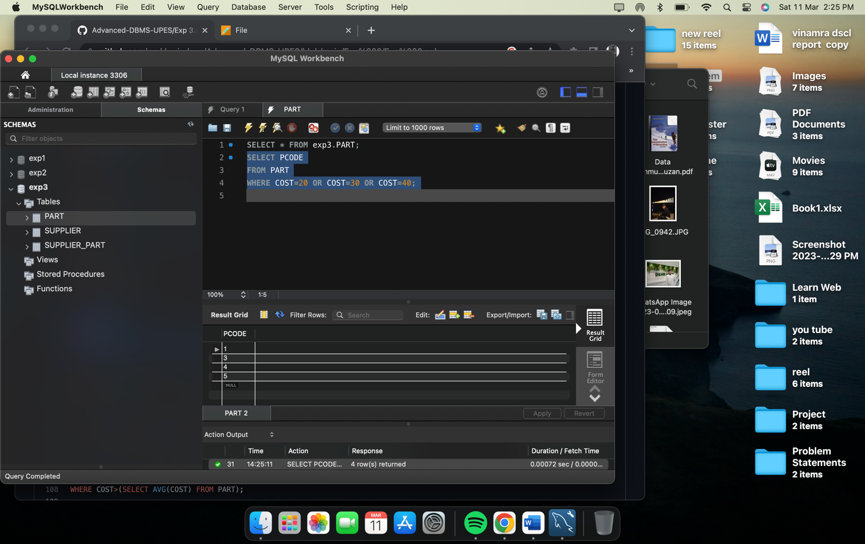

* **Get the total quantity of part 2 that is supplied.**

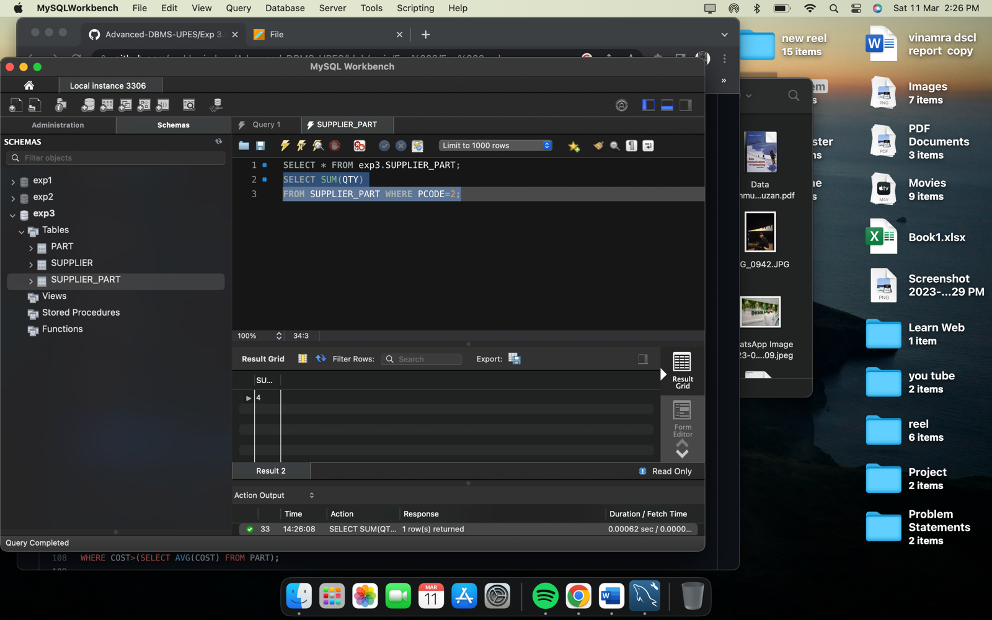

* **Get the name of supplier who supply part 2.**

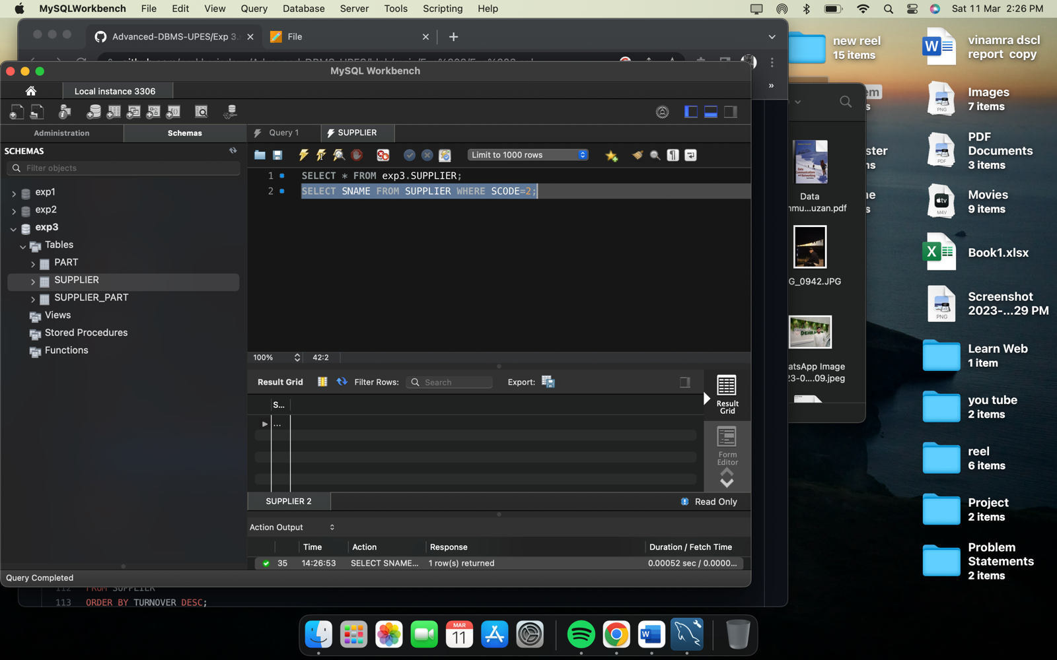

* **Get the part number whose cost is greater than the average cost**

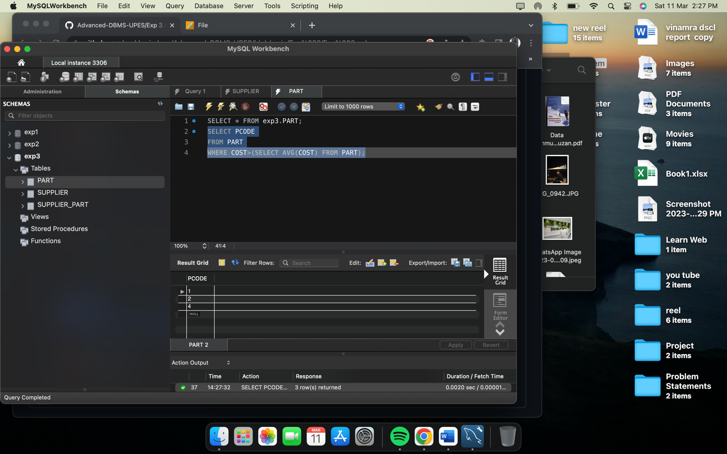

* **Get the supplier number and turnover in descending order of turnover**

